Test Case: tc006_SPX_Dev5_Crear_Requisicion_Spot_Tipo_Cobro_Proyect_Urgent
Step 1 - Enter username and password and click to button Enter: Credentials Entered
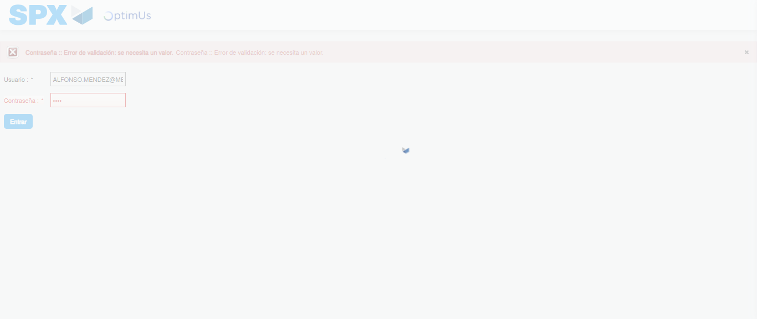Image file-name: QC_Testing-tc006_SPX_Dev5_Crear_Requisicion_Spot_Tipo_Cobro_Proyect_Urgent-1783379119751

Step 2 - Select to UEN and Access to Spot Buy Requisitions : UEN Correctly selected and Correct access
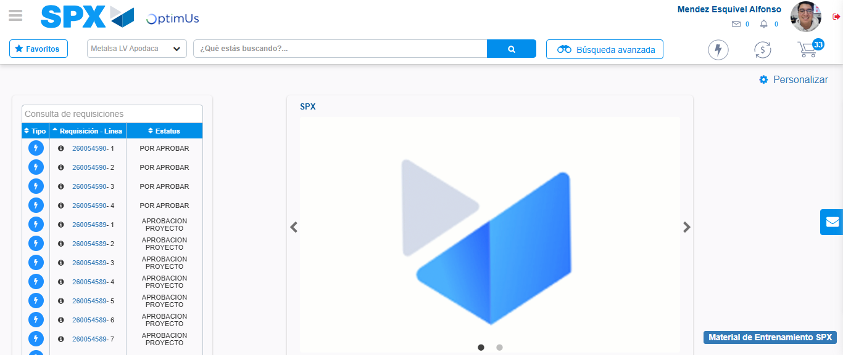Image file-name: QC_Testing-tc006_SPX_Dev5_Crear_Requisicion_Spot_Tipo_Cobro_Proyect_Urgent-1783379145481

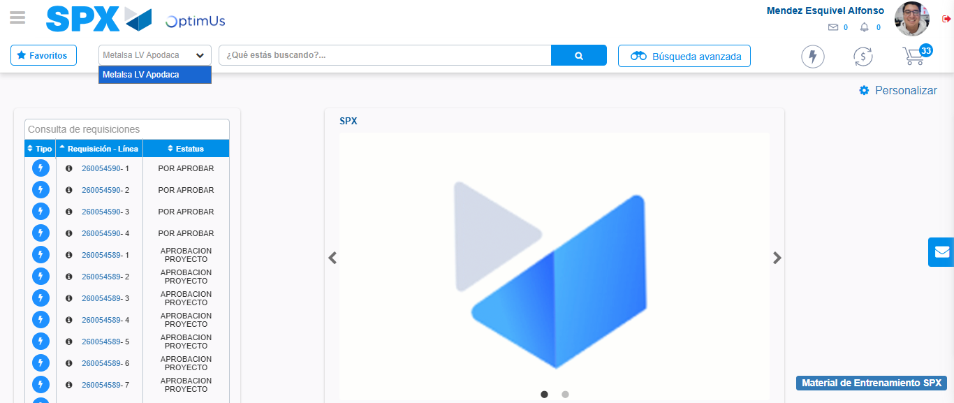Image file-name: QC_Testing-tc006_SPX_Dev5_Crear_Requisicion_Spot_Tipo_Cobro_Proyect_Urgent-1783379148050

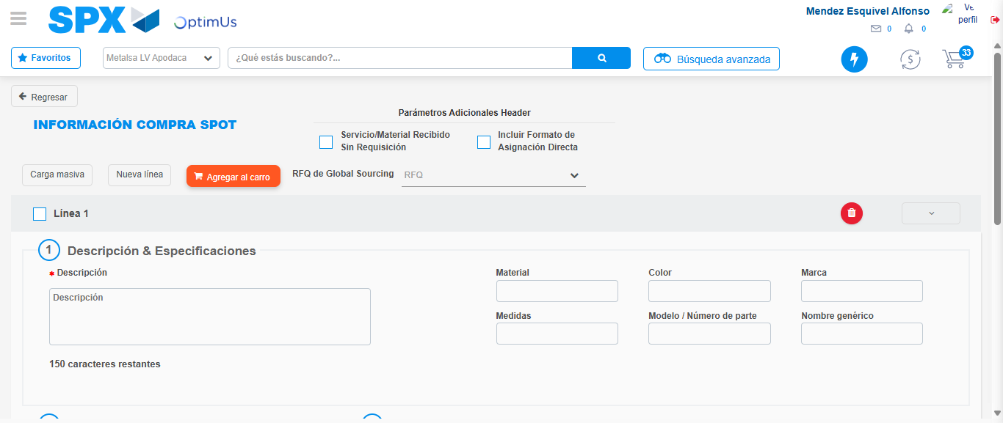Image file-name: QC_Testing-tc006_SPX_Dev5_Crear_Requisicion_Spot_Tipo_Cobro_Proyect_Urgent-1783379170482

Step 3 - Data Capture Spot Buy Requisition: Data captured correctly
Image file-name: QC_Testing-tc006_SPX_Dev5_Crear_Requisicion_Spot_Tipo_Cobro_Proyect_Urgent-1783379170695

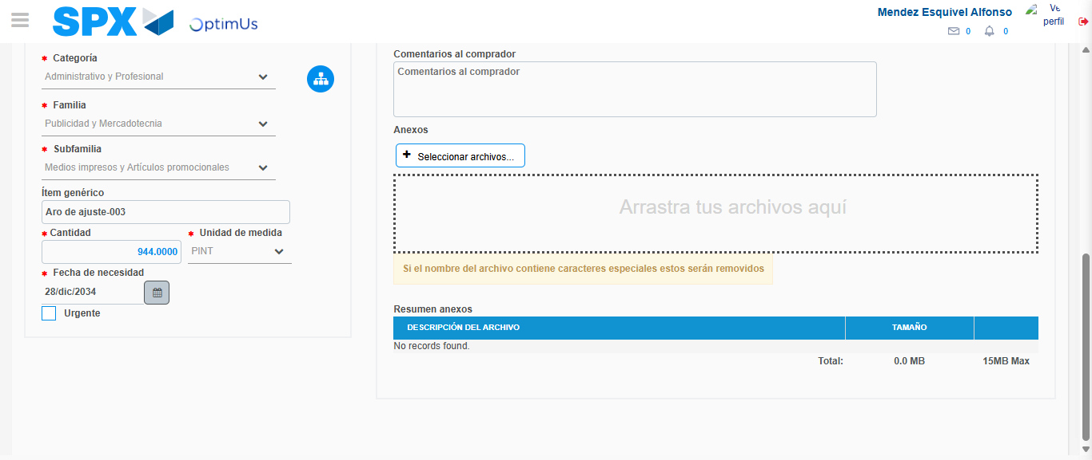Image file-name: QC_Testing-tc006_SPX_Dev5_Crear_Requisicion_Spot_Tipo_Cobro_Proyect_Urgent-1783379181257

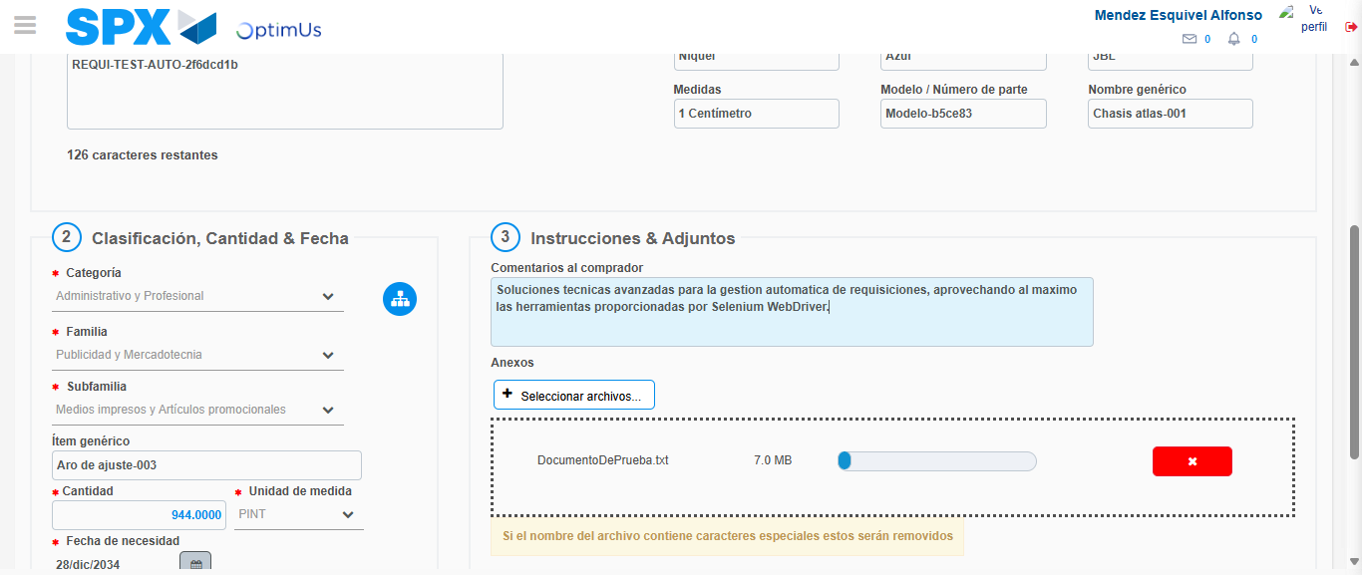Image file-name: QC_Testing-tc006_SPX_Dev5_Crear_Requisicion_Spot_Tipo_Cobro_Proyect_Urgent-1783379182030

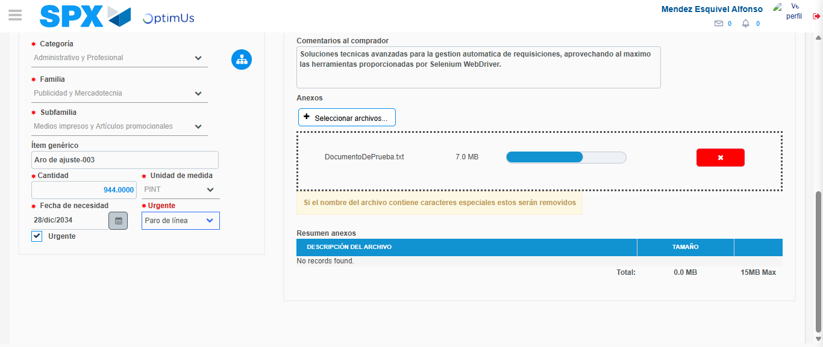Image file-name: QC_Testing-tc006_SPX_Dev5_Crear_Requisicion_Spot_Tipo_Cobro_Proyect_Urgent-1783379185709

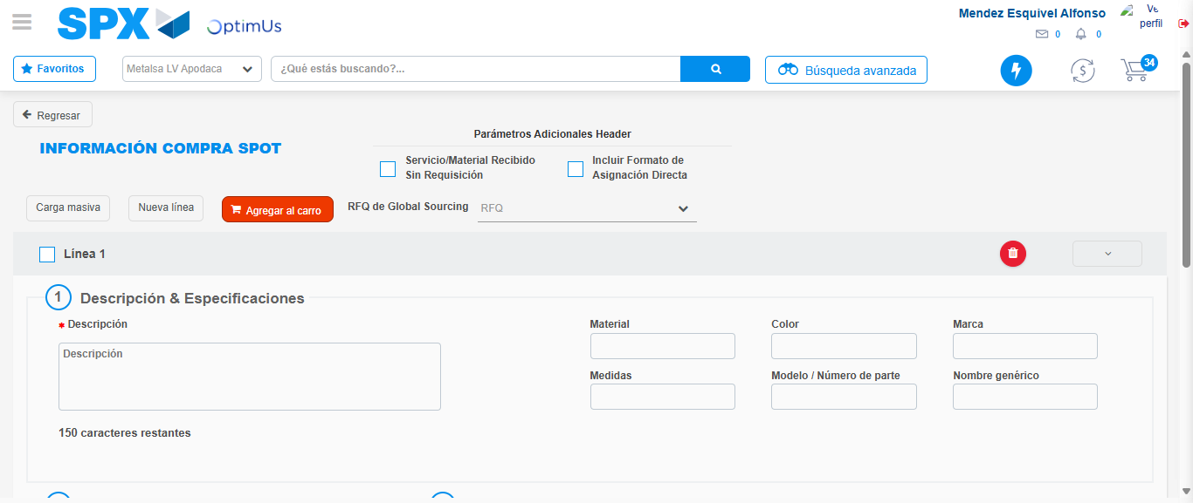Image file-name: QC_Testing-tc006_SPX_Dev5_Crear_Requisicion_Spot_Tipo_Cobro_Proyect_Urgent-1783379193125

Step 7 - Return to Main Page SPX : Return to Main Page SPX
Image file-name: QC_Testing-tc006_SPX_Dev5_Crear_Requisicion_Spot_Tipo_Cobro_Proyect_Urgent-1783379145481

Image file-name: QC_Testing-tc006_SPX_Dev5_Crear_Requisicion_Spot_Tipo_Cobro_Proyect_Urgent-1783379148050

Image file-name: QC_Testing-tc006_SPX_Dev5_Crear_Requisicion_Spot_Tipo_Cobro_Proyect_Urgent-1783379170482

Image file-name: QC_Testing-tc006_SPX_Dev5_Crear_Requisicion_Spot_Tipo_Cobro_Proyect_Urgent-1783379195396

Image file-name: QC_Testing-tc006_SPX_Dev5_Crear_Requisicion_Spot_Tipo_Cobro_Proyect_Urgent-1783379195542

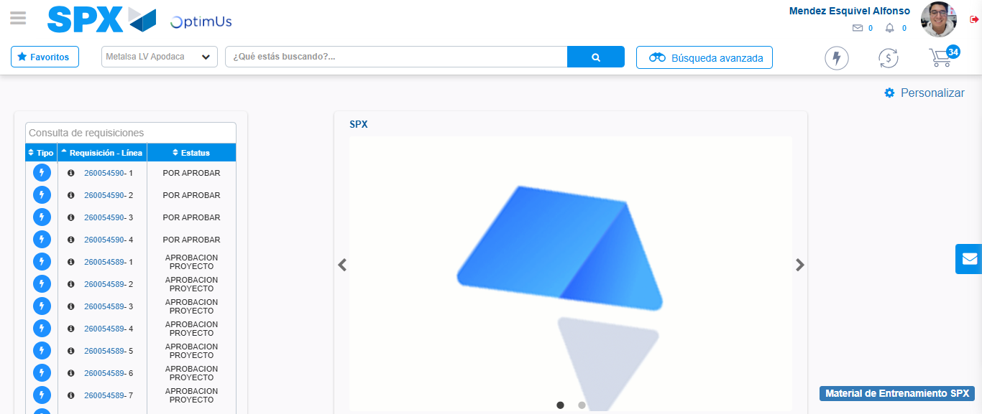Image file-name: QC_Testing-tc006_SPX_Dev5_Crear_Requisicion_Spot_Tipo_Cobro_Proyect_Urgent-1783379216953

Step 8 - Log Out : Log Out SPX
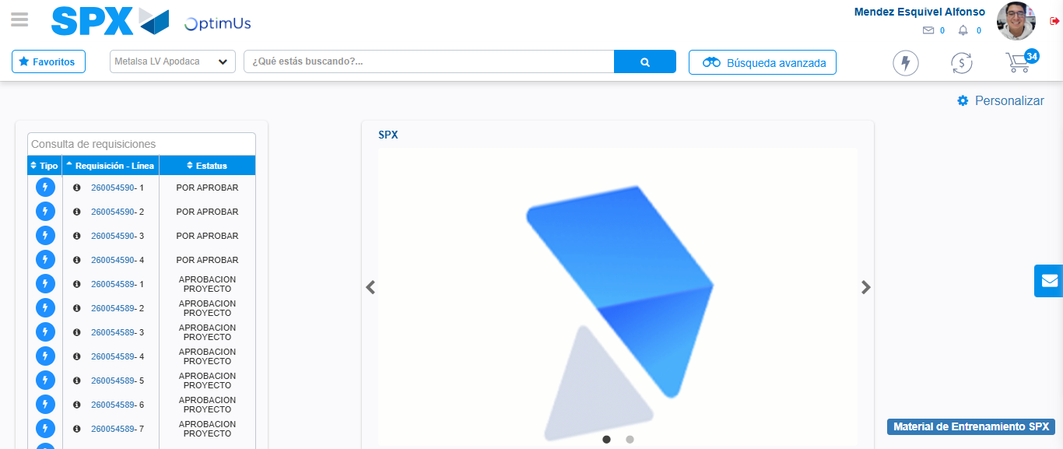Image file-name: QC_Testing-tc006_SPX_Dev5_Crear_Requisicion_Spot_Tipo_Cobro_Proyect_Urgent-1783379217188

